

**Bachelor of Science in Computing**

**Software Engineering**

**Year 2022-23 / Semester 2**

Internal Examiner: Wei Ren

Internal Moderator: Wenhao Fu

External Examiner: Maria Barry

Date: 24/04/2023

Duration: 2 Hours

Time: 10:00-12:00

Exam Weighting: 60%

Exam Delivery: Computer

**Instructions**

1. This paper contains 1 section with 1 question.
2. You must attempt all parts of the question.
3. All questions are marked out of 100.
4. Please write all answers on the script provided.
5. Clearly number all questions.
6. This is an open-book exam.

***Please do not turn over this page until instructed to do so****. The use of programmable or text storing calculators is expressly forbidden. Please note that where a candidate answers more than the required number of questions, the examiner will mark all questions attempted and then select the highest scoring ones.*

**Question 1**

Please answer the question based on the following scenario: You are managing a software development team that has been invited by “Dorset Bank” to develop an operating system for their ATM machines. The ATM machines should allow clients to withdraw money at any time and deposit cash or checks. Additionally, the machines should display the client's account balance. You have 4 weeks to do this project.

1. Select a development method for this project and provide the reason for your choice, (e.g. waterfall development method, agile development method, etc.).

**[14 marks]**

For this project I would suggest an Agile development, due to the complexity of the project, so it would be possible to interact and bring together different teams, this approach is widely used in the market to make it possible to accomplish complex projects such as the given example.

1. Provide a comprehensive list of the steps involved in the software development process.

**[5 marks]**

On this project, the steps can reach a long list, but based on the requirements of the client, it would be a good approach to follow the Scrum, means that all the steps of the development would be spitted into sprints.

Starting from the planning, going for the development, testing, deployment and support, where which steps would follow the basic guidelines as follows:

* Planning, the team would meet for a briefly of the overall objective for this project, for being an financial service, an accountant representative, alongside the developers and a GDPR representative would be a good start to plan how the project should be executed, from the accountant side taking in consider the transactions following the regulations and approach, the GDPR due to the personal data handle by the project as an identifier number to each customer of the Dorset Bank, measures of safety to keep this data private and securely, also to protect it against other users, and the developers would finally discuss further on how to implement the feedback of the others teams.
* Development, the developers would so start to develop the code, algorithm and functions of the overall project, creating the base code, views and safety measures.
* Testing, the team would meet altogether for a testing routine, alongside with specific members of the testing team, the first one would try and see the program running, testing access and functions and the testing team would also do the same, being less bias due to the not straight relationship with the development team.
* Deployment, on this part the project would be deployed in a live environment, the support part of the project would run alongside this step to collect the feedback and improvements from the user interface, and any further concerns or errors that could come up on this phase of the project, so the team would contact again the Development team to start a new cycle and fix any further bugs or required improvements.

1. Write a requirement document based on the client's previous requirements, including functional requirements, interface requirements infrastructure requirements.

**[25 marks]**

The requirements of this project could be as such:

* The ATM hardware where the Operating System would run and mock or artificial hardware that can be emulated to develop the system.
* Since the bank would have ATM machines, means that they would need to be connected trough the internet, so a internet connect would be essential for this project.
* All the mainly hardware of this ATM needs to be available for the development team( Such as the deposit and withdraw hardwere).

1. Create a Use Case Diagram.

**[6 marks]**

A case Diagram of the following project could be represented as follows, it is possible to see the mainly functions of the project, alongside the perform actions that can be done by the customers and some of the functions.

The ()BankBalance method for example, would show the updated bank balance of the user based on his personal ID and perform the calculation if any value is given, for example (100)BankBalance could ad 100 to the bank balance of the user, while (-100)BankBalance could reduce 100 from the bank balance of the user.

Each method would so register a data stamp with the performed action into the database, as per the requirements of this project, the database is not being approached but bear in mind that a Database holding the Account ID and transactions would be needed, alongside with another data for example, the account DB could hold the columns timestamp, machine_ID(The of the machine that makes the transaction), description( If it’s a withdraw, deposit( Check of Cash), and the amount in a double format to handle decimals as per the financial patterns.

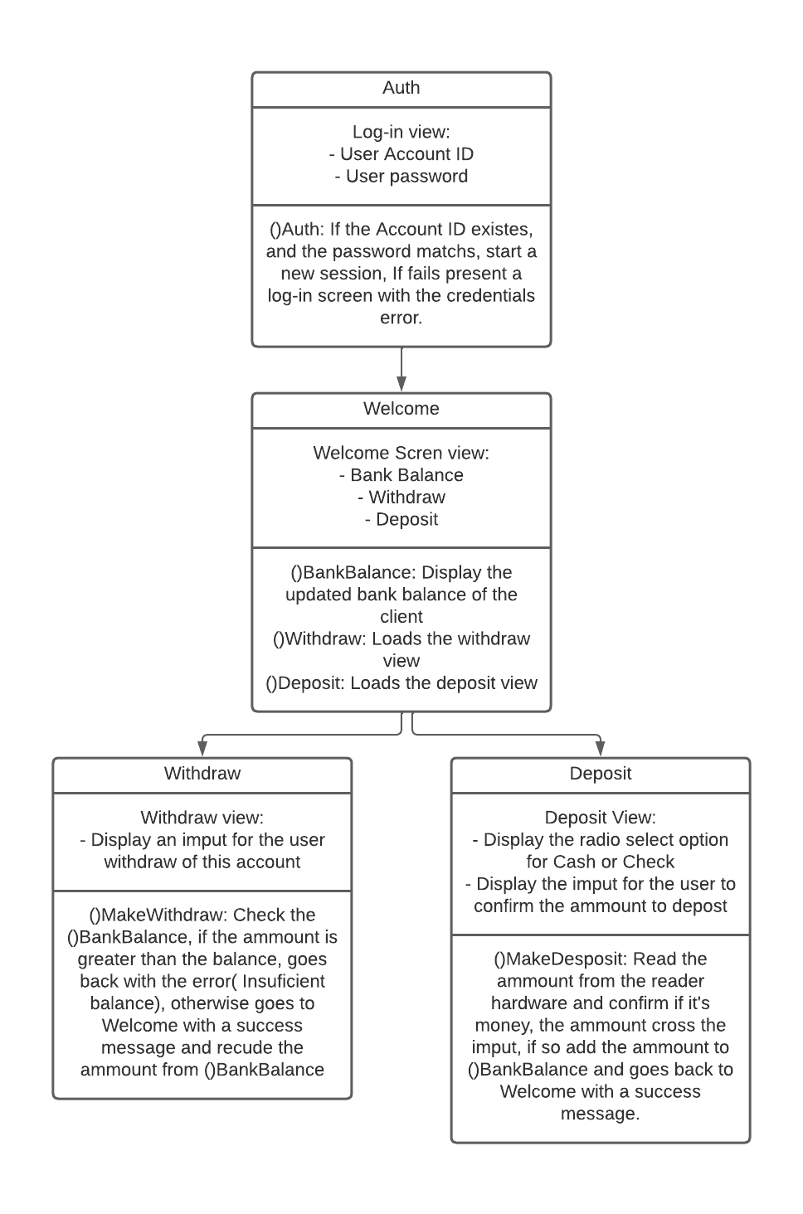

1. Create a Gantt Chart to manage development process.

**[10 marks]**

Following the requirements, and as the project sprint is spitted in weeks, the project would be concluded in 4 weeks.

An easy way to visualize the project would be a Gantt Chart, a widely used view to handle sprints, projects resources and deadlines.

The team would focus on their sprints and window time as below:

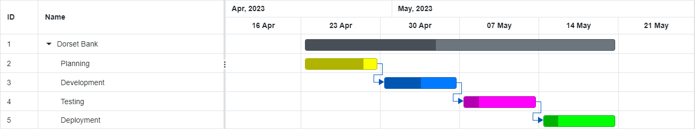

Each sprint is a one week long, starting from planning, going to development, testing and finally deployment.

1. Provide an example code snippet, in any programming language, that includes the class name, function name, and any other necessary variables, to demonstrate how to achieve the goals of this project. You do not need to include the implementation details of the functions. Please show class diagrams or template code.

**[20 marks]**

An example code snippet of ()BankBalance in php would be as follow, bearing in mind that in the given example, the database connection and actions is not detailed:

<?php

public function BankBalance(int ATM_ID, int ID, double ammount = 0, string description = '')

{

$this->ATM_ID = ATM_ID;

$this->ID = ID;

$this->ammount = ammount;

$this->description = description;

#Perform a transaction if an ammount is given

if (ammount != 0) {

$this->SetBankBalance(int ATM_ID, int ID, double ammount = 0, string description = '');

};

#Otherwise just return the GetBankBalance of an given ID

return GetBankBalance(ID);

}

#Get the bank balance of an ID

private static GetBankBalance(ID)

{

#Connect to the database, calculate all the ammount column of an give ID and return the final result

/.../

return bank_balance;

}

#Set a transaction

private static SetBankBalance(int ATM_ID, int ID, double ammount = 0, string description = '')

{

#Connect to the database, and register a transaction based on the int ATM_IDm, ID, ammount and description given(Either positive or negative)

/.../

double set_transaction = ...connect to the DB and register a transaction

}

1. Provide a detailed explanation of the validation and verification process that should be followed to ensure the successful completion of this project.

**[15 marks]**

1. Create a repository on GitHub and upload your answers to it. Please note that the answers on GitHub will not be considered for marking, so it is essential to submit all your answers to Moodle before the exam deadline.

**[5 marks]**

The address of the repository is:

https://github.com/codeitamarjr/Y3S2SoftwareEngineeringFinalExam

**[Total 100 marks]**